Lab 2: Network Commands for Testing and Troubleshooting

Objective:
To familiarize with essential network commands used for testing and troubleshooting network connectivity issues.

Required Tools:
- A computer with command line interface (CLI) access
- Network connection (wired or wireless)

Network Commands:

Syntax and Usage of Common Network Commands:

ping
  - Syntax: ping [hostname or IP address]
  - Usage: Tests the reachability of a host on an IP network and measures the round-trip time for messages sent from the originating host to a destination computer.
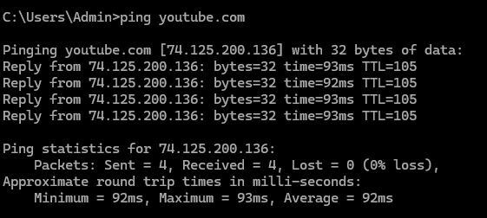

ipconfig (Windows) / ifconfig (Linux)
  - Syntax: ipconfig or ifconfig
  - Usage: Displays all current TCP/IP network configuration values and refreshes DHCP and DNS settings.
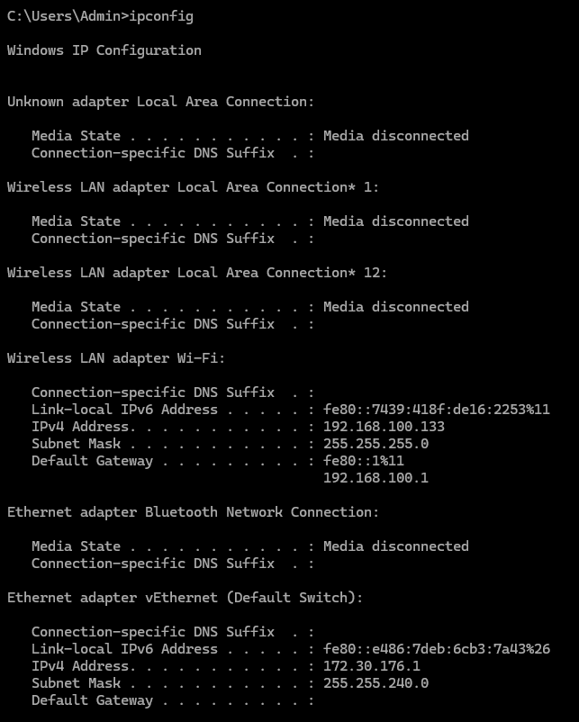

tracert (Windows) / traceroute (Linux)
  - Syntax: tracert [hostname or IP address] or traceroute [hostname or IP address]
  - Usage: Determines the route taken by packets to reach a specific host by listing all the intermediate routers.

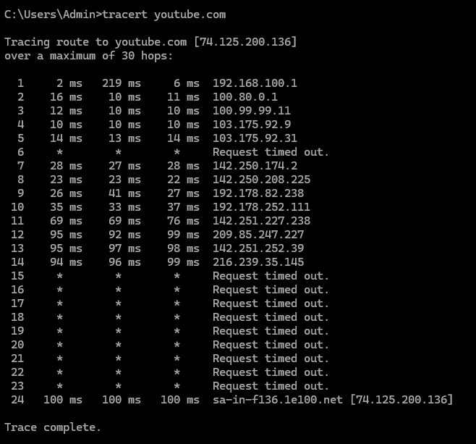

netstat
  - Syntax: netstat -a or netstat -n
  - Usage: Displays active TCP connections, ports on which the computer is listening, Ethernet statistics, and more.

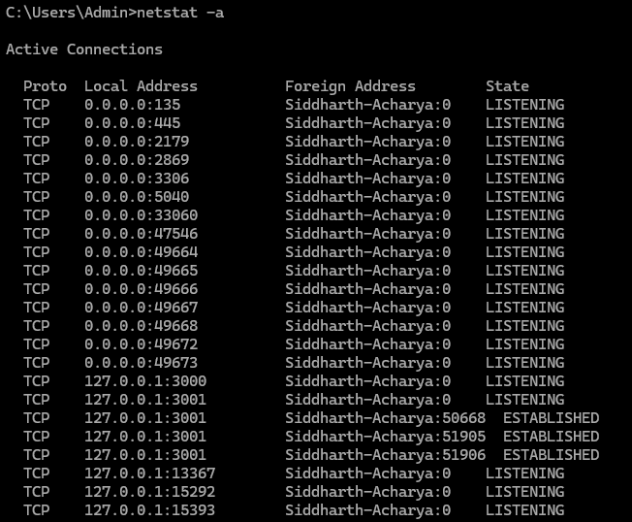
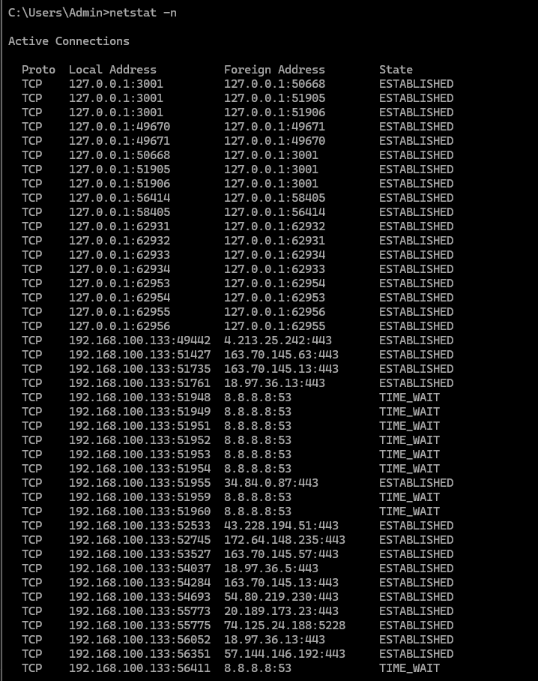

nslookup
  - Syntax: nslookup [hostname]
  - Usage: Queries the Domain Name System (DNS) to obtain domain name or IP address mapping information.
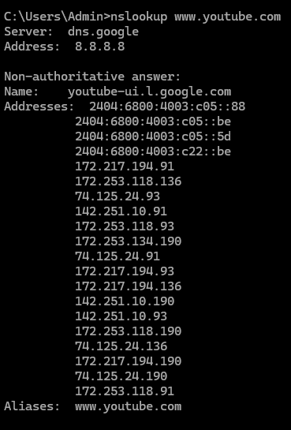

`arp
  - Syntax: arp -a
  - Usage: Displays and modifies the IP-to-Physical (MAC) address translation table used by the Address Resolution Protocol (ARP).
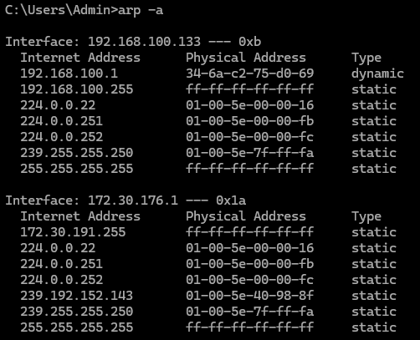

telnet
  - Syntax: telnet [hostname or IP address] [port]
  - Usage: Connects to a remote host using the Telnet protocol, useful for testing connectivity to specific ports.
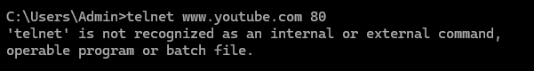
//No output due to installation issue.

netsh wlan (Windows)
  - Syntax: netsh wlan show profiles or netsh wlan connect name=[profile name]
  - Usage: Manages wireless network profiles and connections on Windows systems.
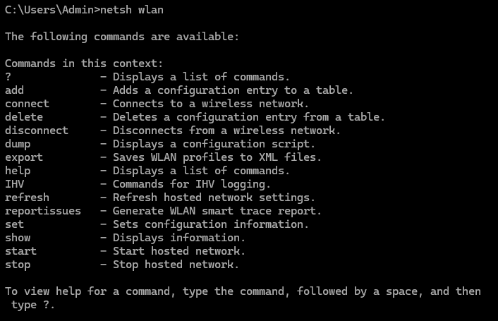

pathping
  - Syntax: pathping [hostname or IP address]
  - Usage: Combines the functionality of ping and tracert to provide information about network latency and packet loss at each hop.
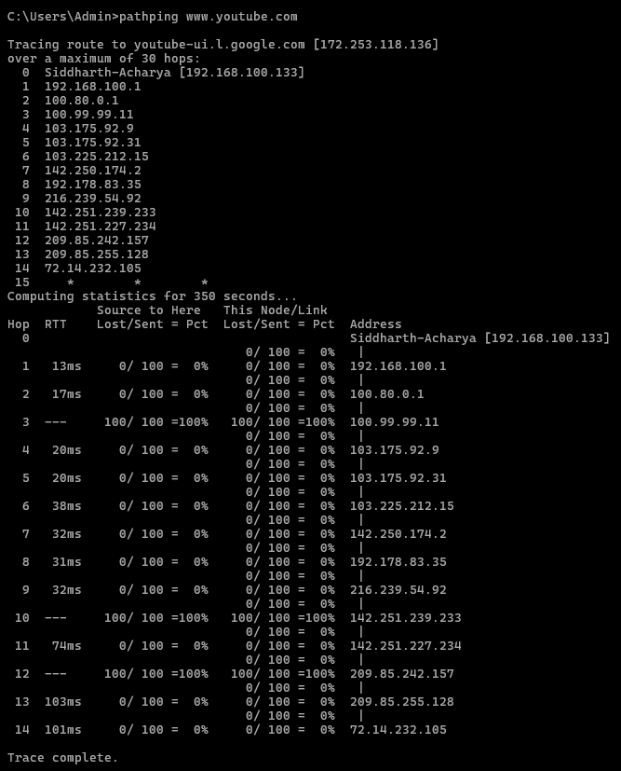

route print
  - Syntax: route print
  - Usage: Displays the current IP routing table on the local machine.
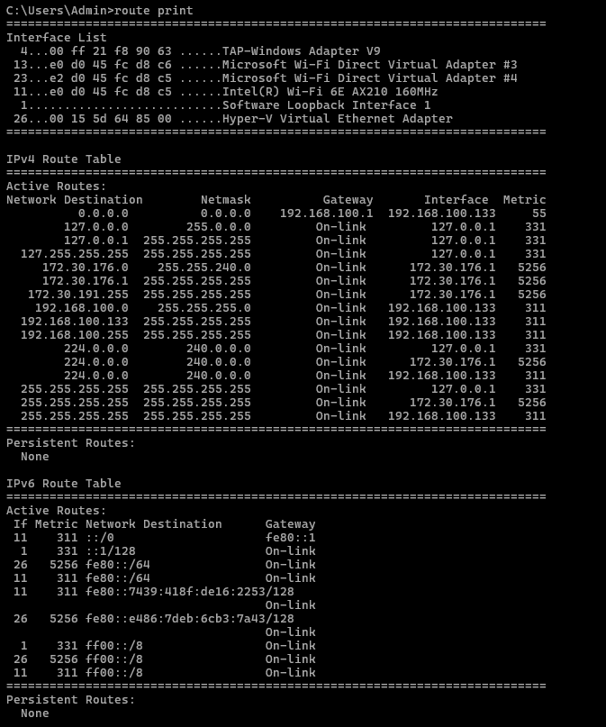

getmac
  - Syntax: getmac
  - Usage: Displays the MAC addresses for network adapters on the local machine.
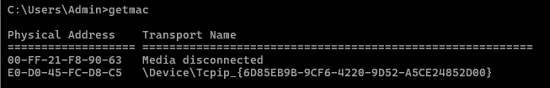

nbtstat
  - Syntax: nbtstat -a [hostname]
  - Usage: Displays NetBIOS over TCP/IP statistics, including the NetBIOS name table of a remote computer.

whois
  - Syntax: whois [domain name]
  - Usage: Retrieves registration information about a domain name from the WHOIS database.
// Some outputs were not displayed due to recognition error.

Procedure
- Open the command line interface (CLI) on your computer.
- Use the ipconfig or ifconfig command to check your current network configuration.
- Usage of the commands are shown in the output files.

Output
All the outputs are attached with the syntax and usage of respective commands.

Conclusion
This lab provided hands-on experience with various network commands essential for diagnosing and troubleshooting network issues. Mastery of these commands is crucial for network administrators and IT professionals to maintain network health and performance.

